Top 1

Eagles Landing

照片你有

**Eagles Landing**  
address:936 Morris Rd,Kent Ohio 44240

330-673-8887

webisite: <http://www.kentapartments.com/>

Top 2

The Province

330-673-8300

website http://www.theprovincekent.com/

address:609 South Lincoln Street,Unit F,Kent,Ohio 44240

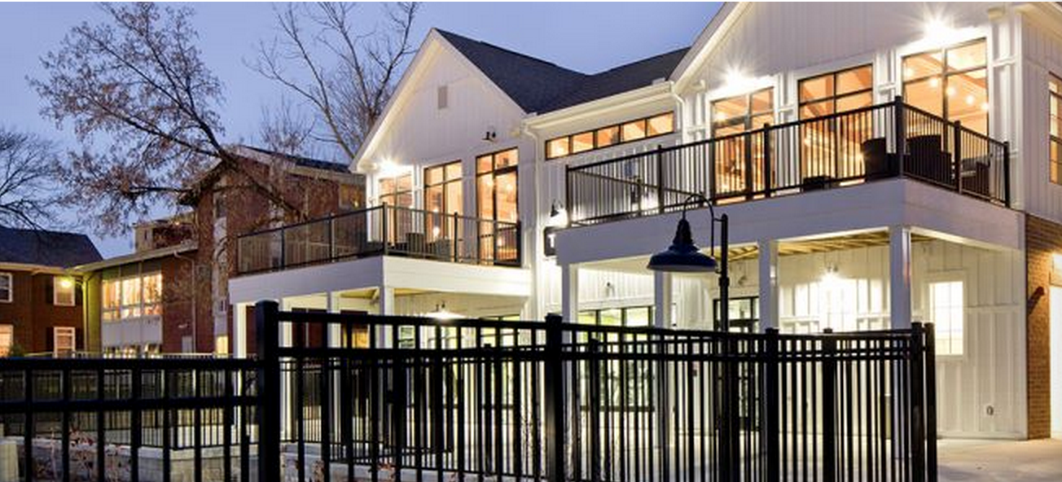

Top 3

UniversityOaks

330-403-4131

website: <http://www.universityoaks-kent.com>

address: 500 Golden Oaks Drive  
Kent, OH 44240

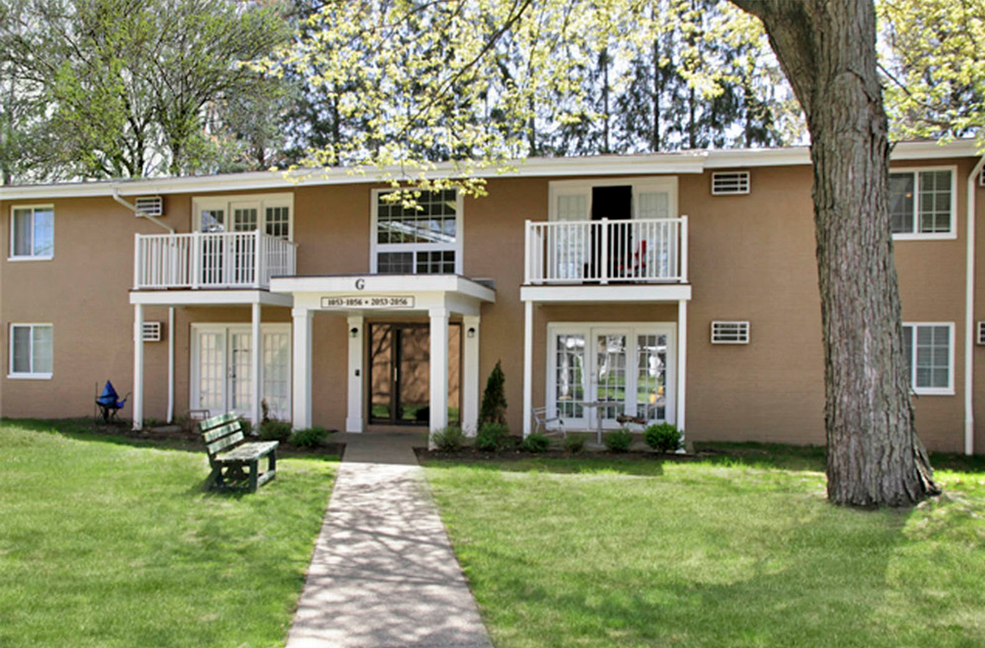

Top4

Holly Park

330-678-0823

address: 1652 Mulberry Ct.#112

website: <http://www.kentapartments.com>

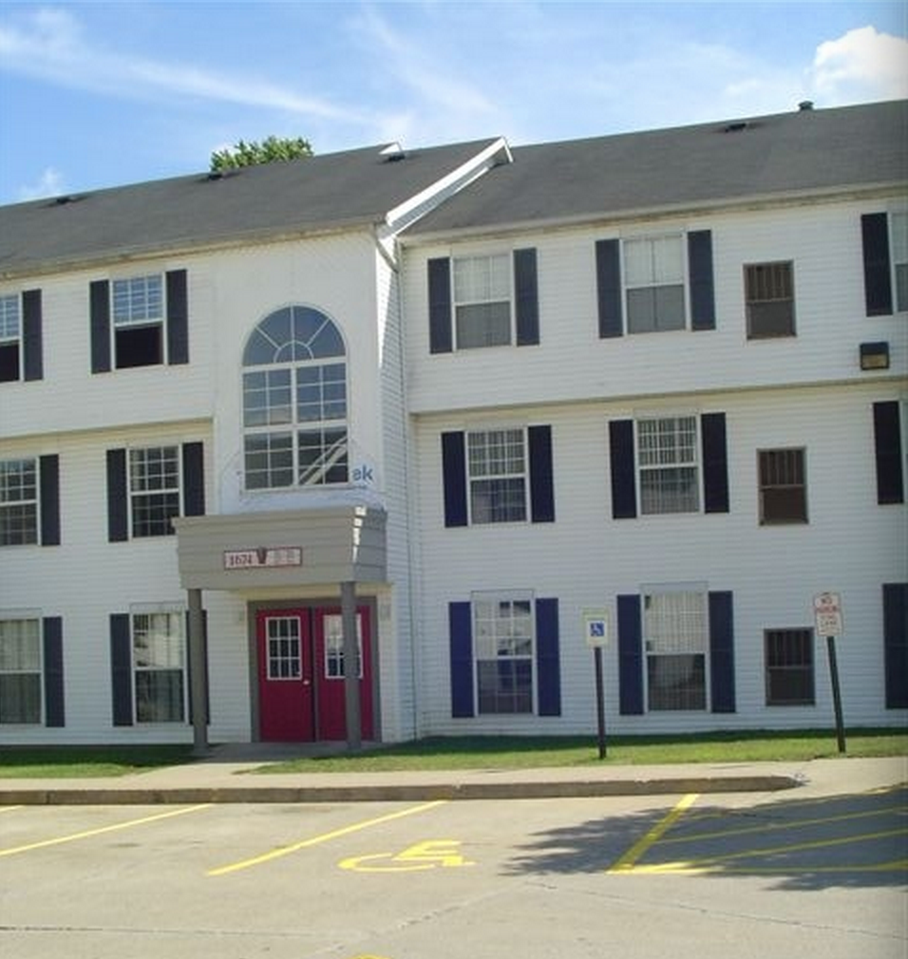

Top 5

Campus Pointe

Address:1841 ASHTON LANE | KENT, OH 44240 |

330.673.2202

website: <http://campuspointekent.com>

